**EXPERIMENT NO -02**

**1-ARITHMETIC OPERATOR**

# 1_b_arthemtic operators in python are

# 1-addition(+)  2-subtraction(-)  3-multiplication(*)  4-division(/)  5-modulus(%)  6-exponention(**)  7-Floor division(//)

#addition

x1 = 10

y1 = 20

print("addition is==>",x1 + y1)

#subtraction

x2 = 50

y2 = 20

print("subtraction is==>",x2 - y2)

#multiplication

x3 = 10

y3 = 20

print("multiplication is==>",x3 * y3)

#division

x4 = 16

y4 = 4

print("division is==>",x4 / y4)

#modulus

x5 = 30

y5 = 12

print("reminder is==>",x5 % y5)

#exponention

x6 = 2

y6 = 3

print("2^3 is==>",x6**y6)

#floor division

x7 = 15

y7 = 2

print("results rounds to nearesr whole number==>",x7 // y7)#the floor division // rounds the result down to the nearest whole number

**OUTPUT:**

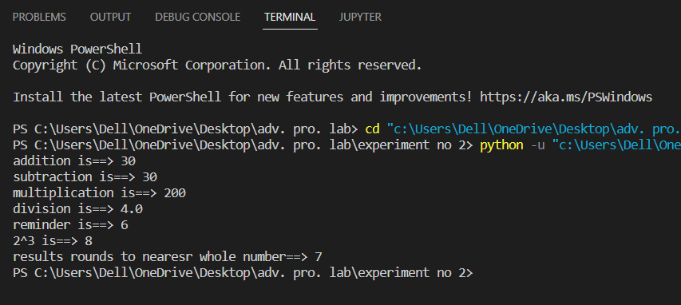

**2-ASSIGNMENT OPERATOR**

# C_Programs showing operations using Assignment Operators,

#assignment operators in python are: =,+=,-=,*=,/=,%=,//=,**=,&=,|=,^=,>>=,<<=

#1- "="

x1 = 5

print("value of x1==>",x1)

#2- "+="

x2 = 10

x2 += 4

print("value of x2==>",x2)

#3- "-="

x3 = 10

x3 -= 4

print("value of x3==>",x3)

#4- "*="

x4 = 10

x4 *= 4

print("value of x4==>",x4)

#5- "/="

x5 = 10

x5 /= 4

print("value of x5==>",x5)

#6- "%="

x6 = 10

x6 %= 4

print("value of x6==>",x6)

#7- "//="

x7 = 10

x7 //= 4

print("value of x7==>",x7)

#8- "**="

x8 = 10

x8 **= 4

print("value of x8==>",x8)

#9- "&="

x9 = 10

x9 &= 4

print("value of x9==>",x9)

#10- "|="

x10 = 10

x10 |= 4

print("value of x10==>",x10)

#11- "^="

x11 = 10

x11 ^= 4

print("value of x11==>",x11)

#12- ">>="

x12 = 10

x12 >>= 4

print("value of x12==>",x12)

#13- "<<="

x13 = 10

x13 <<= 4

print("value of x13==>",x13)

**OUTPUT:**

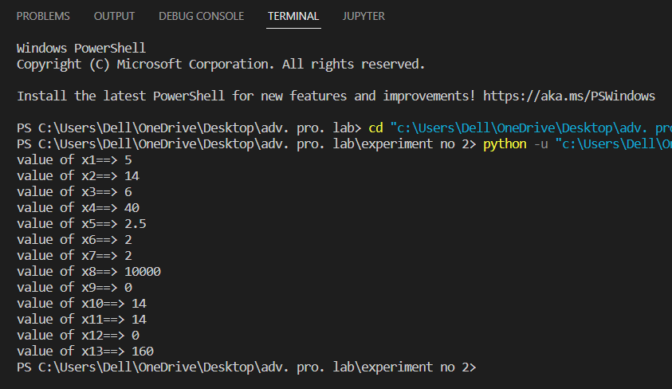

**3-COMPAIRISION OPERATOR**

# Programs showing operations using Comparison Operators,

# compairision operators in python are: "==","!=",">","<",">=","<="

# 1- "=="

x1 = 10

y1 = 15

print(x1 == y1)# returns False because 5 is not equal to 3

# 2- "!="

x2 = 10

y2 = 15

print(x2 != y2)# returns False because 5 is not equal to 3

# 3- ">"

x3 = 10

y3 = 15

print(x3 > y3)

# 4- "<"

x4 = 10

y4 = 15

print(x4 < y4)

 # 5- ">="

x5 = 10

y5 = 15

print(x5 >= y5)

# 6- "<="

x6 = 10

y6 = 15

print(x6 <= y6)

**OUTPUT:**

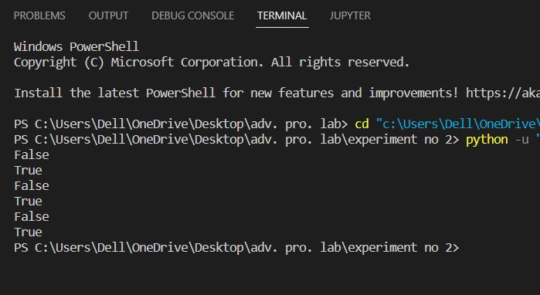

**4-LOGICAL OPERATOR**

# E_logical operator in python

#logical oprators are: 1-AND 2-OR 3-NOT

# 1- AND

x1 = 15

print(x1 > 10 and x1 < 20)

# 2- OR

x = 15

print(x > 10 or x < 20)

# 3- NOT

x = 15

print(not(x > 10 and x < 20))

**OUTPUT:**

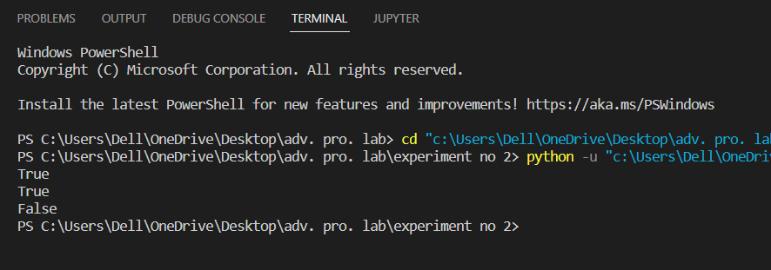

**5-BITWISE OPERATOR**

from ast import operator

# F_bitwise operators

# bitwise operators in python are: AND(&), OR(|), XOR(^), NOT(~), left shift(<<),right shift(>>)

a = 60            # 60 = 0011 1100

b = 13            # 13 = 0000 1101

c = 0

c = a & b;        # 12 = 0000 1100

print("0011 1100 & 0000 1101 =", c)

c = a | b;        # 61 = 0011 1101

print("0011 1100 | 0000 1101 ==>", c)

c = a ^ b;        # 49 = 0011 0001

print("0011 1100 ^ 0000 1101 ==>", c)

c = ~a;           # -61 = 1100 0011

print("0011 1100 ~ ==>", c)

c = a << 2;       # 240 = 1111 0000

print("0011 1100 << ==>", c)

c = a >> 2;       # 15 = 0000 1111

print("0011 1100 >> ==>", c)

**OUTPUT:**

